**Name:** Safyan Anwar

**Roll no:** BSSE-24-018

**Assignment #:** 3

**Section:** 3A-BSSE

**Submitted to:** Sir. Rasikh

**LAB # 3:**

**Task: “insert_at_head”:-**

**Code:**

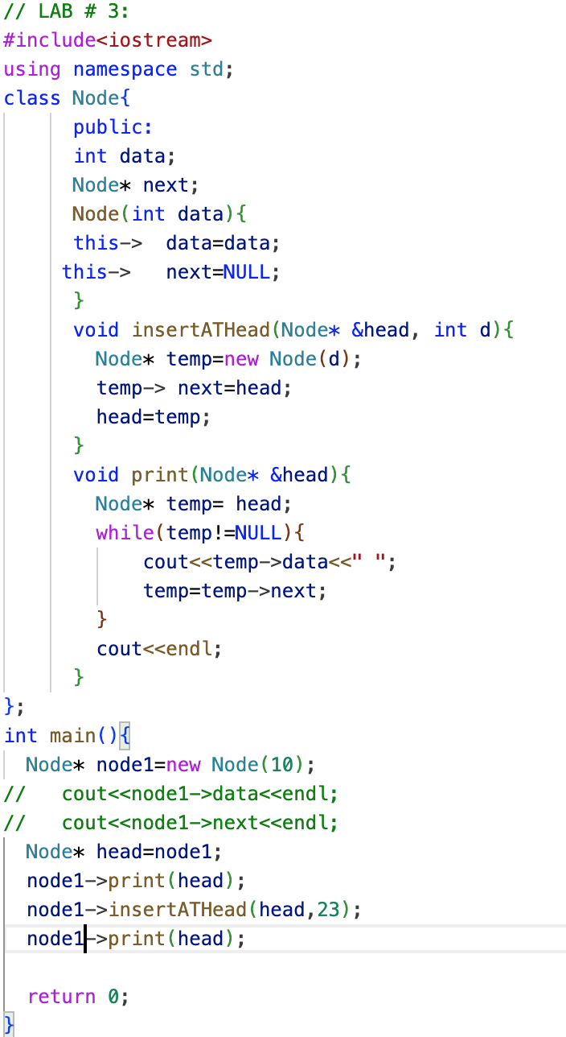

**Output:**



**Explanation:**

The ‘node’ class represents a node in a linked list with a constructor to initialize the node data and next pointer. The ‘insertATHead’ method inserts a new node at the head of the list. ‘Print’ its traverse through the linked list starting from the head printing each node data until it reaches the end NULL. And main function new node node1 is created with a value of 10. A pointer head is set to point to node1. It insert a new node with the value 23 at the head of the list.

**Task: “insert_at_tail”:-**

**Code:**

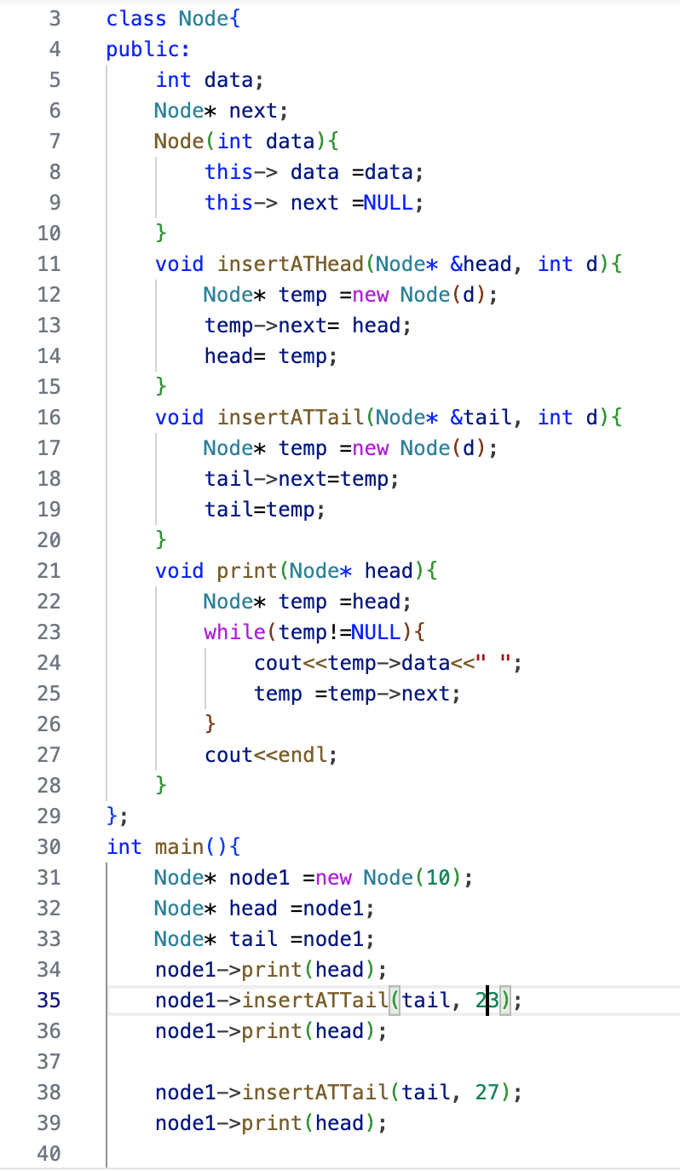

**Output:**

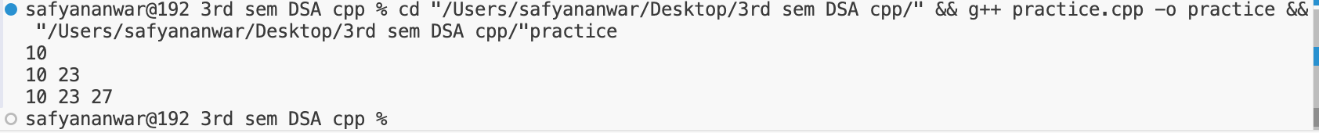

**Explanation:**

“The ‘node’ class represents a node in a linked list with a constructor to initialize the node data and next pointer. The ‘insertATHead’ method inserts a new node at the head of the list. ‘Print’ its traverse through the linked list starting from the head printing each node data until it reaches the end NULL. The ‘insertATTail’ insert a new node at the end of the list. And main function new node node1 is created with a value of 10. A pointer head is set to point to node1. It insert a new node with the value 23 at the head of the list. Tail initialize to the same node inserting of new nodes with data 23 and 27 at the tail.”